Data Set 1:

|  |  |
| --- | --- |
| Year Born | Year Died |
| 1900 | 1910 |
| 1900 | 2000 |
| 1900 | 1910 |
| 1900 | 1920 |
| 1900 | 1930 |
| 1900 | 1940 |
| 1900 | 1950 |
| 1900 | 1960 |
| 1900 | 1970 |
| 1900 | 1980 |

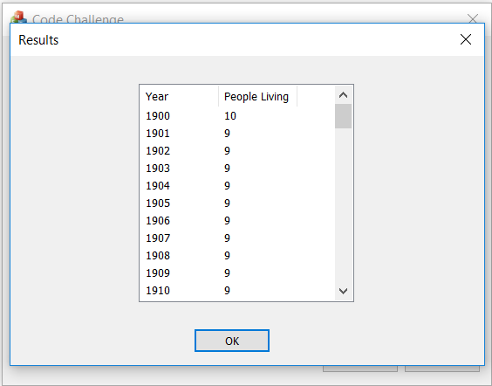

Data Set 2:

|  |  |
| --- | --- |
| Year Born | Year Died |
| 1901 | 1910 |
| 1911 | 1920 |
| 1921 | 1930 |
| 1931 | 1940 |
| 1941 | 1950 |
| 1951 | 1960 |
| 1961 | 1970 |
| 1971 | 1980 |
| 1981 | 1990 |

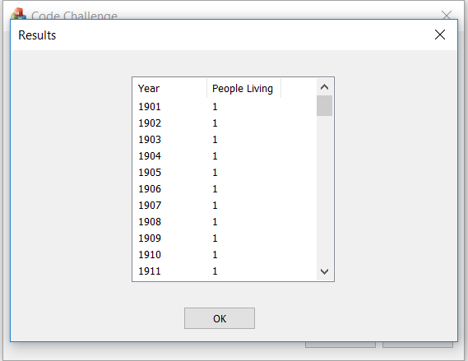

Data Set 3:

|  |  |
| --- | --- |
| Year Born | Year Died |
| 1900 | 1950 |
| 1911 | 1910 |
| 1980 | 1920 |
| 1965 | 1930 |
| 1950 | 1940 |
| 1952 | 1950 |
| 1948 | 1960 |
| 1934 | 1970 |
| 1945 | 1980 |

